Задача 8. Найти производную.
8.1. 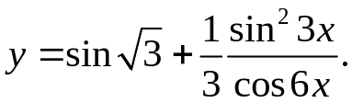
y'= 6sin3xcos3xcos6x+3(1-cos6x)sin6x = sin12x+2sin6x-sin12x = tg6x_
3cos² 6x 3cos² 6x cos6x
8.2. 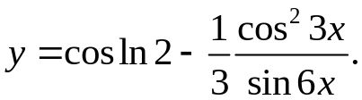
y'= 6cos3xsin3xsin6x+3(cos6x+1)cos6x = 3sin² 6x+3cos² 6x+3cos6x = 1+cos6x = 1+cos6x
6sin² 6x 6sin² 6x 2sin² 6x 1-cos12x
8.3. 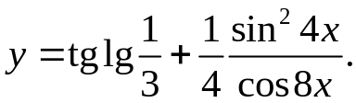
y'= 8sin4xcos4xcos8x+4(1-cos8x)sin8x = 2sin16x+4sin8x-2sin16x = tg8x_
4cos² 8x 4cos² 8x cos8x
8.4. 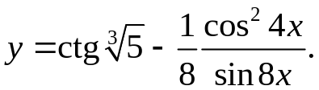
y'= 8cos4xsin4xsin8x+4(cos8x+1)cos8x = 4sin² 8x+4cos² 8x+4cos8x = 1+cos8x = 1+cos8x
8sin² 8x 8sin² 8x 2sin² 8x 1-cos16x
8.5. 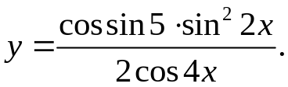
y'= cossin5*4sin2xcos2xcos2x+2(1-cos4x)sin4x = cossin5*sin8x+2sin4x-sin8x = cossin5*tg4x_
2cos² 4x 2cos² 4x cos4x
8.6. 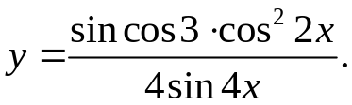
y'= -sincos3*4cos2xsin2xsin4x+2(cos4x+1)cos4x=sincos3*2sin²4x+2cos² 4x+2cos4x=sincos3*1+cos4x= sincos3*1+cos4x
4sin² 4x 4sin² 4x 2sin² 4x 1-cos8x
8.7. 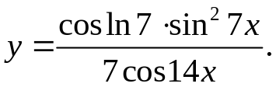
y'=cosln7*14sin7xcos7xcos14x+7(1-cos14x)sin14x=cosln7*sin28x+2sin14x-sin28x=cosln7* tg14x_
7cos² 14x 2cos² 14x cos14x
8.8. 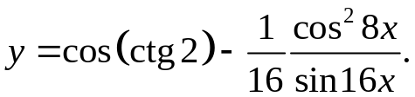
y'= 16cos8xsin8xsin16x+8(cos16x+1)cos16x = 8sin² 16x+8cos² 16x+8cos16x =
16sin² 16x 16sin² 16x
= 1+cos16x = 1+cos16x
2sin² 16x 1-cos32x
8.9. 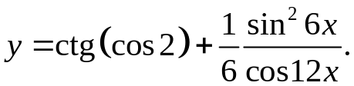
y'= 12sin6xcos6xcos12x+6(1-cos12x)sin12x = sin24x+2sin12x-sin24x = tg12x_
6cos² 12x 2cos² 12x cos12x
8.10. 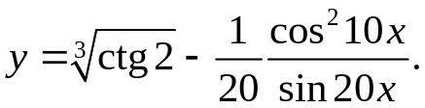
y'= 20cos10xsin10xsin20x+10(cos20x+1)cos20x =10sin² 20x+10cos² 20x+10cos20x=
20sin² 20x 20sin² 20x
= 1+cos20x = 1+cos20x
2sin² 20x 1-cos40x
8.11. 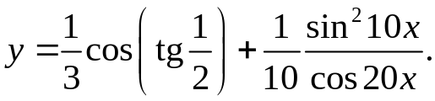
y'= 20sin10xcos10xcos20x+10(1-cos20x)sin20x =
10cos² 20x
= 5sin40x+10sin20x-5sin40x = tg20x_
10cos² 20x cos20x
8.12. 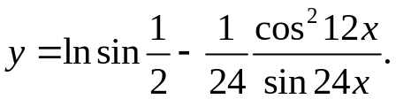
y'= 24cos12xsin12xsin24x+12(cos24x+1)cos24x= 12sin² 24x+12cos² 24x+12cos24x=
24sin² 24x 24sin² 24x
= 1+cos24x = 1+cos24x
2sin² 24x 1-cos48x
8.13. 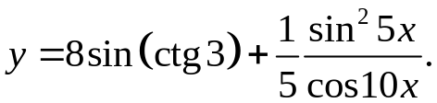
y'= 10sin5xcos5xcos10x+5(1-cos10x)sin10x =
5cos² 10x
= sin20x+2sin10x-sin20x = tg10x_
2cos² 10x cos10x
8.14. 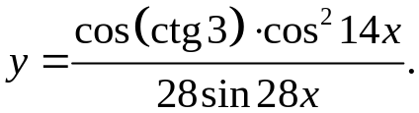
y'= -cosctg3*28cos14xsin14xsin28x+14(cos28x+1)cos28x = -cosctg3*14sin² 28x+14cos² 28x+14cos28x =
28sin² 28x 28sin² 28x
= -cosctg3*1+cos28x = -cosctg3*1+cosx
2sin² 28x 1-cos56x
8.15. 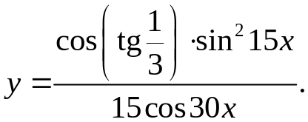
y'= costg1/3*30sin15xcos15xcos30x+15(1-cos30x)sin30x =
15cos² 30x
= costg1/3*sin60x+2sin30x-sin60x = costg1/3* tg30x_
2cos² 30x cos30x
8.16. 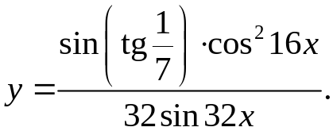
y'= - sintg1/7*32cos16xsin16xsin32x+16(cos32x+1)cos32x = - sintg1/7*16sin² 32x+16cos² 32x+16cos32x =
32sin² 32x 32sin² 32x
= - sintg1/7*1+cos32x = - sintg1/7*1+cos32x
2sin² 32x 1-cos64x
8.17. 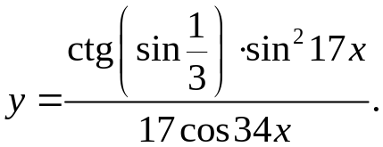
y'= ctgsin1/3*34sin17xcos17xcos34x+17(1-cos34x)sin34x =
17cos² 34x
= ctgsin1/3*sin68x+2sin34x-sin68x = ctgsin1/3* tg34x_
2cos² 34x cos34x
8.18. 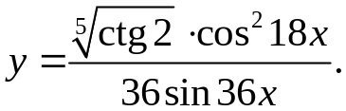
y'= - ⁵√ctg2*36cos18xsin18xsin36x+18(cos36x+1)cos36x = - ⁵√ctg2*18sin² 36x+18cos² 36x+cos36x =
36sin² 36x 36sin² 36x
= - ⁵√ctg2*1+cos36x = - ⁵√ctg2*1+cos36x
2sin² 36x 1-cos72x
8.19. 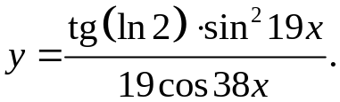
y'= tgln2*38sin19xcos19xcos38x+19(1-cos38x)sin38x =
19cos² 38x
= tgln2*sin76x+2sin38x-sin76x = tgln2* tg38x_
2cos² 38x cos38x
8.20. 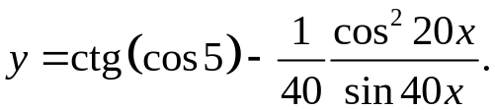
y'= 40cos20xsin20xsin40x+20(cos40x+1)cos40x = 20sin² 40x+20cos² 40x+20cos40x =
40sin² 40x 40sin² 40x
= 1+cos40x = 1+cos40x
2sin² 40x 1-cos80x
8.21. 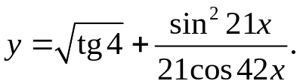
y'= 42sin21xcos21xcos42x+21(1-cos42x)sin42x =
21cos² 42x
= sin84x+2sin42x-sin84x = tg42x_
2cos² 42x cos42x
8.22. 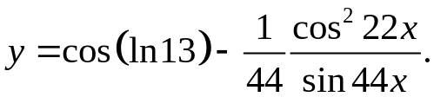
y'= 44cos22xsin22xsin44x+22(cos44x+1)cos44x = 22sin² 44x+22cos² 44x+22cos44x =
44sin² 44x 44sin² 44x
= 1+cos44x = 1+cos44x
2sin² 44x 1-cos88x
8.23. 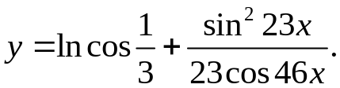
y'= 46sin23xcos23xcos46x+23(1-cos46x)sin46x =
23cos² 46x
= sin92x+2sin46x-sin92x = tg46x_
2cos² 46x cos46x
8.24. 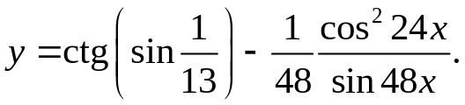
y'= 48cos24xsin24xsin48x+24(cos48x+1)cos48x = 24sin² 48x+24cos² 48x+24cos48x =
48sin² 48x 48sin² 48x
= 1+cos48x = 1+cos48x
2sin² 48x 1-cos96x
8.25. 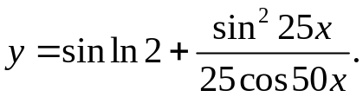
y'= 50sin25xcos25xcos50x+25(1-cos50x)sin50x =
25cos² 50x
= sin100x+2sin50x-sin100x = tg50x_
2cos² 50x cos50x
8.26. 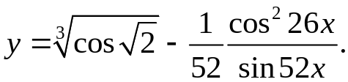
y'= 52cos26xsin26xsin52x+26(cos52x+1)cos52x = 26sin² 52x+26cos² 52x+26cos52x =
52sin² 52x 52sin² 52x
= 1+cos52x = 1+cos52x
2sin² 52x 1-cos104x
8.27. 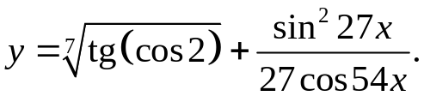
y'= 54sin27xcos27xcos54x+27(1-cos54x)sin54x =
27cos² 54x
= sin108x+2sin54x-sin108x = tg54x_
2cos² 54x cos54x
8.28. 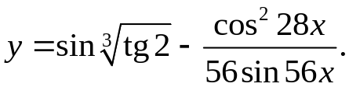
y'= 56cos28xsin28xsin56x+28(cos56x+1)cos56x = 28sin² 56x+28cos² 56x+28cos56x =
56sin² 56x 56sin² 56x
= 1+cos56x = 1+cos56x
2sin² 56x 1-cos112x
8.29. 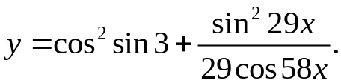
y'= 58sin29xcos29xcos58x+29(1-cos58x)sin58x =
29cos² 58x
= sin116x+2sin58x-sin116x = tg58x_
2cos² 58x cos58x
8.30. 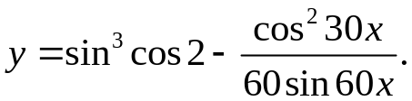
y'= 60cos30xsin30xsin60x+30(cos60x+1)cos60x = 30sin² 60x+30cos² 60x+30cos60x =
60sin² 60x 60sin² 60x
= 1+cos60x = 1+cos60x
2sin² 60x 1-cos120x
8.31. 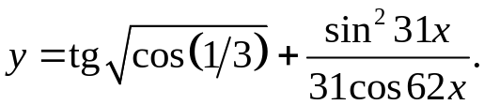
y'= 62sin31xcos31xcos62x+31(1-cos62x)sin62x =
31cos² 62x
= sin124x+2sin62x-sin124x = tg62x_
2cos² 62x cos62x

